**SOFTWARE**

**TABLAS DE DECISIÓN**

**Álvaro Gracia Aledo**

30/11/2023

1º DAM

**ACTIVIDAD 3 – TABLAS DE DECISIÓN**

**1. Simplificar y eliminar las redundancias de la siguiente tabla de decisión (TD). Determina las importancias.**

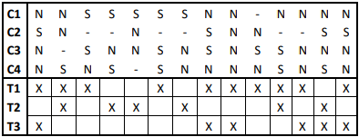

|  | **8** | **4** | **4** | **4** | **1** |  |  |
| --- | --- | --- | --- | --- | --- | --- | --- |
|  |  |  |  |  |  |  |  |
|  | **3** | **1** | **2** | **4** | **13** |  |  |
| **C1** | **-** | **N** | **N** | **S** | **N** | **13** | **S - N = 2** |
| **C3** | **S** | **-** | **-** | **N** | **N** | **13** | **S - N = 1** |
| **C4** | **-** | **N** | **S** | **-** | **S** | **9** | **S - N =1** |
| **C2** | **-** | **-** | **-** | **-** | **S** | **1** |  |
|  |  |  |  |  |  |  |  |
| **T1** | **X** | **X** | **X** |  |  |  |  |
| **T2** |  |  | **X** | **X** | **X** |  |  |
| **T3** |  | **X** |  |  | **X** |  |  |

**2. Realiza la tabla de decisión, simplificala, determina sus importancias y realiza el ordinograma en el siguiente caso: Una persona desea efectuar un crucero por el mediterráneo, pero solo puede realizarlo si obtiene algún ingreso extra. Por ello va a jugar a la lotería, quinielas y primitiva.**

|  | **1** | **2** | **3** | **4** | **5** | **6** | **7** | **8** |
| --- | --- | --- | --- | --- | --- | --- | --- | --- |
| **LOTERIA** | **S** | **S** | **S** | **S** | **N** | **N** | **N** | **N** |
| **QUINIELA** | **S** | **S** | **N** | **N** | **S** | **S** | **N** | **N** |
| **PRIMITIVA** | **S** | **N** | **S** | **N** | **S** | **N** | **S** | **N** |
|  |  |  |  |  |  |  |  |  |
| **CRUCERO** | **X** | **X** | **X** | **X** | **X** | **X** | **X** |  |
| **NO CRUCERO** |  |  |  |  |  |  |  | **X** |

|  | **2** | **2** | **2** | **1** | **1** |  |
| --- | --- | --- | --- | --- | --- | --- |
|  | **1** | **3** | **5** | **7** | **8** |  |
| **LOTERIA** | **S** | **S** | **N** | **N** | **N** | **8** |
| **QUINIELA** | **S** | **N** | **S** | **N** | **N** | **8** |
| **PRIMITIVA** | **-** | **-** | **-** | **S** | **N** | **2** |
|  |  |  |  |  |  |  |
| **CRUCERO** | **X** | **X** | **X** | **X** |  |  |
| **NO CRUCERO** |  |  |  |  | **X** |  |

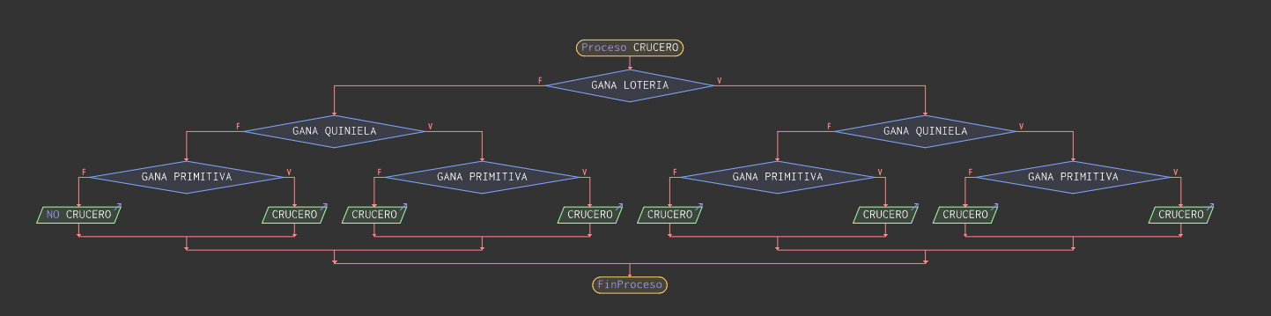

**3. Realiza la tabla de decisión, simplifica, determina las importancias y realiza el ordinograma del siguiente caso. Funcionamiento de un semáforo que contempla las siguientes situaciones: - Amarillo intermitente: Pasar - Verde o verde con amarillo fijo: Pasar - Rojo o rojo con amarillo fijo: Parar**

|  | **1** | **2** | **3** | **4** | **5** | **6** | **7** | **8** |
| --- | --- | --- | --- | --- | --- | --- | --- | --- |
| **VERDE / VERDE y AMARILLO** | s | s | s | s | n | n | n | n |
| **AMARILLO INTERMITENTE** | s | s | n | n | s | s | n | n |
| **ROJO / ROJO Y AMARILLO** | s | n | s | n | s | n | s | n |
|  |  |  |  |  |  |  |  |  |
| **PASAR** |  |  |  | x |  | x |  |  |
| **PARAR** |  |  |  |  |  |  | x |  |
| **IMPOSIBLE** | x | x | x |  | x |  |  | x |

|  | **8** | **4** | **1** | **1** |  |
| --- | --- | --- | --- | --- | --- |
|  | **1** | **4** | **7** | **8** |  |
| **ROJO / ROJO Y AMARILLO** | - | n | s | n | 6 |
| **VERDE / VERDE y AMARILLO** | - | - | n | n | 2 |
| **AMARILLO INTERMITENTE** | - | - | n | n | 2 |
|  |  |  |  |  |  |
| **PASAR** |  | x |  |  |  |
| **PARAR** |  |  | x |  |  |
| **IMPOSIBLE** | x |  |  | x |  |

